**Matthew Hardenburg – GAME 420 Major Project Write-Up**

When I started the major project, I initially wanted to create a game in unity. My original idea was a click to move RPG with a story in a five-act structure with around seven entirely different zones. I launched myself into learning Unity, and while I feel as if I have a good baseline now, it would have taken far too long to create an (in my opinion) acceptable game for submission. As the deadline began to loom on the horizon, I altered the story down to what is presented in my submission. Eventually, I realized that I wouldn’t have time to finish the project in Unity given my inexperience, so I transitioned to Twine sugarcube, given my experience with Twine on the minor project.

To start, I had to decide on my Twine story format. When I chose to use sugarcube over Harlowe, I discovered that I could write the code in its own .twee file using my IDE. Then, I could use a program called TweeGo to compile all the .twee and required assets into the resulting .html document. For me, this was way more comfortable and intuitive to me than it was using the Twine editor while creating the minor project. From there I was able to begin development

One of the largest challenges I faced when creating the game was learning the intricacies of the sugarcube language. However, when it finally clicked, I was able to work at a steady pace with few problems. Any bugs I was able to find, I squashed. Overall, the most difficult part was working out the combat system. However, I was able to reuse the skeleton of the code from the combat system included in my minor project. From there I implemented unique spells with cooldowns for each class, as well as finite consumable health potions. This effectively fixes two of the largest concerns that arose from my minor project (why not just spam spells/infinite heal).

Overall, I’m pleased with what I was able to produce. The game has follows a narrative without any bugs (that I know of!), and has an effective combat system based on the Dungeons and Dragons rules for hits/misses. When it comes to balancing, each class is overpowered in its own way due to their unique spell and their stat boosts. In addition to that, it all boils down to the behind-the-scenes dice roll. There have been many instances where one moment I felt like I was overpowered, and then the next I missed 4 attacks in a row and am on death’s door. In my opinion, this style of combat replicates the intricacies of a real battle, taking into account the Dungeons and Dragons rule of six seconds per combat round. Realistically, there is more I wish I would have been able to include, such as: audio, multiple spells, the original five-act story, etc. However, with my late switch to Twine, there simply was not time to do so. In the end, I created a working, playable game that my friends enjoyed, with much less criticism than my minor project; I consider this a success.

A few examples of bugs I posted to my discord server, and found by my testers:

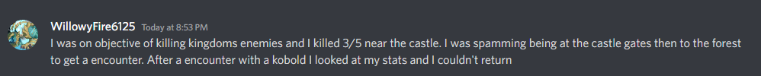

Play-tester Feedback:

**Kyle a.k.a Snek**

  
**Mackenzie a.k.a wizardman115**

**Calvert a.k.a Aran** (my most loyal fan)

**Willow**

